Type of Error

Syntax Error:

Error in language structure. For example, forget semicolon or citation.

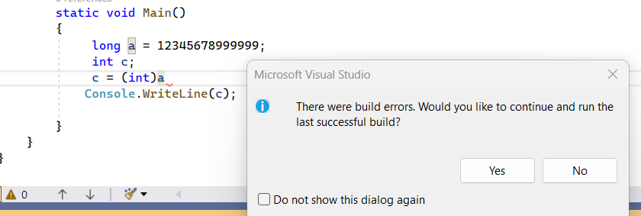

Syntax error never allowed program to run or compile. here semicolon is missing

Logical Error:

The program is running will but the result is wrong. That main you have written wrong operator for example: math operations without brackets

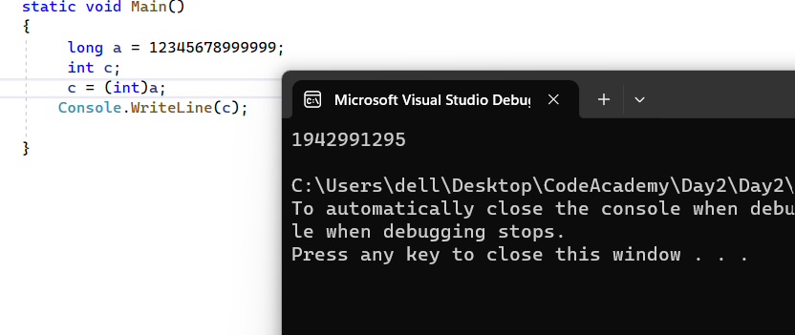

Logical error. The program run but give wrong result because we convert long to Int which is smaller than long.

Runtime Error:

Error occurred after compiler. For example, dividing to 0 or convert long to int using checked method.

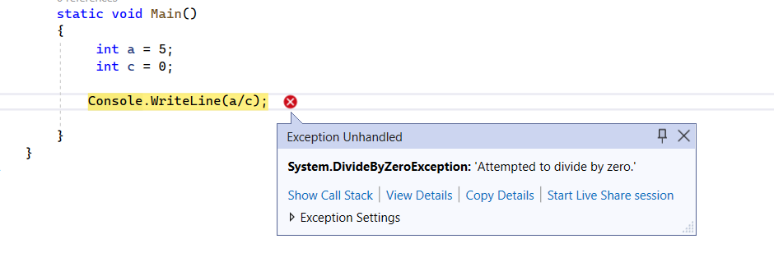

The program give exception becouse can not divide to 0.

Warning Error:

It is not error but just warning that you have something more efficient to use.

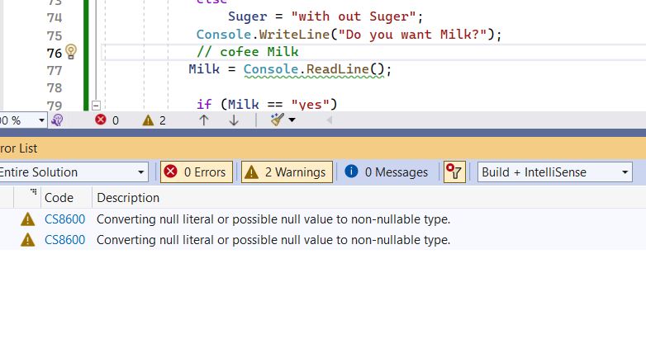

The program is running well but there is warning null literal. Null can case error sometime in the future.